

Higher Institute of Engineering & Technology, El-Beheira

Computer Engineering Department

Second assignment in numerical analysis

(Guass Elimination)

Under supervision of Dr.Mahmoud Gamal

|  |  |
| --- | --- |
| Team | ID |
| Mohamed Yosry El-Zarka | 19100 |
| Youssef Mohamed El-Sheheimy | 19124 |
| Omar Abd Al-Halim Khalil | 19138 |

**Source code in C++:-**

1 #include<iostream>  
2 #include<iomanip>  
3 using namespace std;  
4  
5 void intro();  
6 void input_matrix(double Matrix[100][100],int* n);  
7 void print_matrix(double Matrix[100][100],int n);  
8 void Gauss_Elimination(double Matrix[100][100],int n);  
9 void BACKWARD_SUBSTITUTION(double Matrix[100][100],double res[100],int n);  
10 void print_solution(double res[100],int n);  
12 int main()  
13 {  
14 intro();  
15 double Matrix[100][100], res[100];  
16 int n;  
17 while(1)  
18 {  
19 input_matrix( Matrix , &n );  
20 cout << "\n ---------------------------------\n";  
21 cout << "\n AUG Matrix is:\n";  
22 print_matrix( Matrix , n );// Printing AUG original Matrix  
23 Gauss_Elimination( Matrix , n ); // Gauss Elimination  
24 cout << "\n Matrix after Gauss Elimination is:\n";  
25 print_matrix( Matrix , n ); //Printing the Matrix after Gauss Elimination  
26 BACKWARD_SUBSTITUTION( Matrix , res , n ); // BACKWARD SUBSTITUTION  
27 print_solution( res , n ); // OUTPUT  
28 cout<<"\nTry anther one\n";  
29 }  
30 return 0;  
31 }  
32  
33 void intro()  
34 {  
35 cout<<"Project for 'Numerical Analysis' under the supervision of Dr.  
Mahmoud Gamal.\n";  
36 cout<<"by:\n\t\tMohamed Yosry ElZarka 19100.\n\t\tYoussef Mohamed  
ElSheheimy 19124.\n\t\tOmar Abd Al-Halim Khalil 19138.\n";  
37 cout<<"\nThis is a program to calculate the solution of a system of  
linear equations using Gauss Elimination.\n";  
38 cout<<"The user can determine the number of equations to be solved.\n";  
39 }  
40  
41 void input_matrix(double Matrix[100][100],int* n)  
42 {  
43 cout << "\nEnter the number of equations: ";  
44 cin >> *n;  
45 cout << "Enter Elements of each row of the AUG matrix with the dimensions  
of (" << *n << " Rows X " << *n+1 <<" Columns)\n";  
46 for (int i = 0; i < *n; i++)  
47 {  
48 cout << "\tEnter Row #" << i + 1 << ": ";  
49 for (int j = 0; j < *n + 1; j++)  
50 cin >> Matrix[i][j];  
51 }  
52 }  
53  
54 void print_matrix(double Matrix[100][100],int n)  
55 {  
56 for (int i = 0; i < n; i++)  
57 {  
58 for (int j = 0; j < n + 1; j++)  
59 {  
60 if(j==n)cout <<"| ";  
61 cout<< setw(6) << setprecision(2) << Matrix[i][j];  
62 }  
63 cout << endl;  
64 }  
65 cout << "\n ---------------------------------\n";  
66 }  
67  
68 void Gauss_Elimination(double Matrix[100][100],int n)  
69 {  
70 for (int j = 0; j < n - 1; j++)  
71 for (int i = j + 1; i < n; i++)  
72 {  
73 double op = Matrix[i][j] / Matrix[j][j];  
74 for (int k = 0; k < n + 1; k++)  
75 Matrix[i][k] -= Matrix[j][k] * op;  
76 }  
77 }  
78  
79 void BACKWARD_SUBSTITUTION(double Matrix[100][100],double res[100],int n)  
80 {  
81 for (int i = n - 1; i >= 0; i--)  
82 {  
83 double op = 0.0;  
84 for (int j = i + 1; j < n; j++)  
85 op += Matrix[i][j] * res[j];  
86 res[i] = (Matrix[i][n] - op) / Matrix[i][i];  
87 }  
88 }  
89  
90 void print_solution(double res[100],int n)  
91 {  
92 cout << "\n The Solution is:\n";  
93 for (int i = 0; i < n; i++)  
94 cout << "x[" << i + 1 << "]=" << setw(5) << setprecision(11) << res[i  
] << endl;  
95 cout << "\n ---------------------------------\n";  
96 }

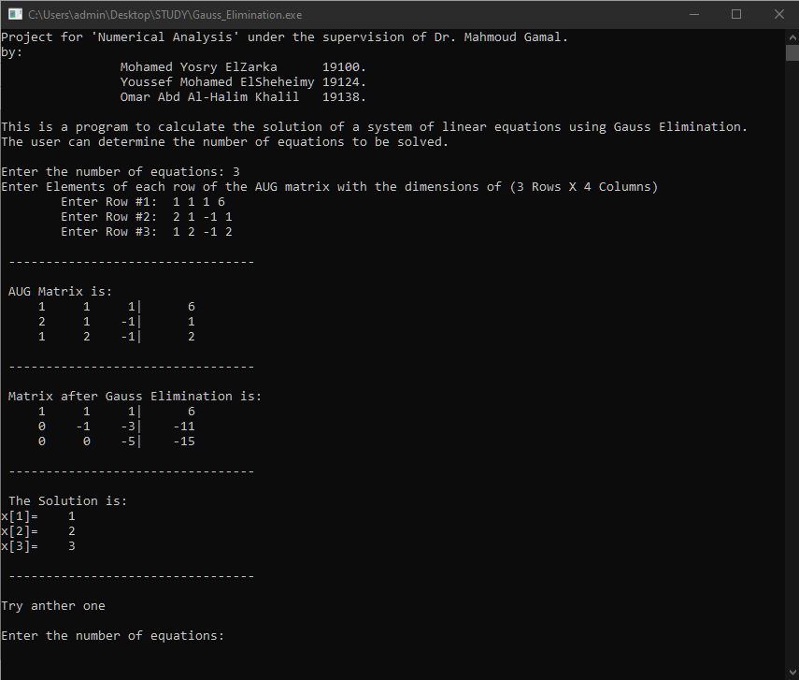**The program in C++:-**